Supplementary Material
- Methods
- Variables included in LCA model for the Ovidius-TripleP cohort and the STEP cohort
- eFigure 1: Continuous variables by class assignment in a three, four, or five-class model for the Ovidius-TripleP cohort and the STEP cohort.
- eFigure 2: Probability of class assignment for the Ovidius-TripleP cohort and the STEP cohort.
- eTable 1 Ovidius-TripleP cohort and STEP cohort baseline characteristics
- eTable 2 Contigency tables comparing class membership of the reduced model compared to the full model
- Clinical characteristics for each class in a three-class model in Ovidius-TripleP and STEP cohort

- Methods
Definition of CAP
CAP was defined as a new pulmonary infiltrate on chest x-ray, accompanied by at least one of the following criteria: cough, sputum, temperature >38ºC (or <35ºC), auscultatory findings consistent with pneumonia, C-reactive protein >15 mg/L, leukocyte count >10x10⁹ cells/L or <4x10⁹ cells/L, or >10% bands in leucocyte differentiation.[1, 2]
Systemic biomarkers
Systemic concentrations of inflammatory biomarkers were measured in plasma samples obtained on the day of hospital admission before administration of any study medication. Samples were stored at -80ºC. Analysis was performed using multiplex multi-analyte profiling (Millipore, Billerica, USA), as described previously.[3, 4] Different biomarker panels were used in the Ovidius-TripleP cohort and the STEP cohort (Table 1).

References:
1. Fine MJ, Singer DE, Hanusa BH, Lave JR, Kapoor WN. Validation of a pneumonia prognostic index using the MedisGroups Comparative Hospital Database. Am J Med 1993: 94(2): 153-159.
2. Niederman MS, Mandell LA, Anzueto A, Bass JB, Broughton WA, Campbell GD, Dean N, File T, Fine MJ, Gross PA, Martinez F, Marrie TJ, Plouffe JF, Ramirez J, Sarosi GA, Torres A, Wilson R, Yu VL, American Thoracic S. Guidelines for the management of adults with community-acquired pneumonia. Diagnosis, assessment of severity, antimicrobial therapy, and prevention. American journal of respiratory and critical care medicine 2001: 163(7): 1730-1754.
3. Endeman H, Meijvis SC, Rijkers GT, van Velzen-Blad H, van Moorsel CH, Grutters JC, Biesma DH. Systemic cytokine response in patients with community-acquired pneumonia. The European respiratory journal 2011: 37(6): 1431-1438.
4. Urwyler SA, Blum CA, Coslovsky M, Mueller B, Schuetz P, Christ-Crain M. Cytokines and Cortisol - predictors of treatment response to corticosteroids in community-acquired pneumonia? J Intern Med 2019: 286(1): 75-87.

2. Variabels included in LCA model for the Ovidius-TripleP cohort and the STEP cohort

2A Class defining variables included in the latent-class analysis of the Ovidius-TripleP cohort
Age
Systolic blood pressure
Diastolic blood pressure
Symptom duration
Oxygen saturation
Body temperature
Heart rate
Respiratory rate
PSI score
Creatinine
Urea
Albumin
ALAT
ASAT
Alkaline phosphatase (U/L)
LDH
Bilirubin
Glucose
Sodium
CRP
White blood cell count
Thrombocyte count
Hemoglobin
Hematocrit
pH
PaO2
PaCO2
Interleukin-1 receptor antagonist
Interleukin-5
Interleukin-6
Interleukin-8
Interleukin-10
Interleukin-12
Monocyte chemoattractant protein
Macrophage inflammatory protein
Tumour necrosis factor alpha
Interferon gamma
2B Class defining variables included in the latent-class analysis of the STEP cohort
Diastolic blood pressure
Symptom duration
Oxygen saturation
Heart rate
Respiratory rate
PSI score
Creatinine
Urea
Glucose
CRP
Procalcitonin
Neutrophils
White blood cell count
Interleukin-1 beta
Interleukin-1 receptor antagonist
Interleukin-2
Interleukin-4
Interleukin-6
Interleukin-8
Interleukin-10
Interleukin-12
Interleukin-13
Interleukin-17
Granuolcyte-colonony stimulating factor
Monocyte chemoattractant protein
Tumour necrosis factor alpha
Interferon alpha
Interferon beta
Interferon gamma

3. eFigure 1
eFigure 1A Continuous variables by class assignment in a three, four, or five-class model in the Ovidius-TripleP cohort. On the Y-axis differences in the standardised values of each variable by subgroup are shown. The individual continuous variables are shown along the x-axis. Variables are sorted by degree of separation between classes.
Three-class model Ovidius-TripleP cohort
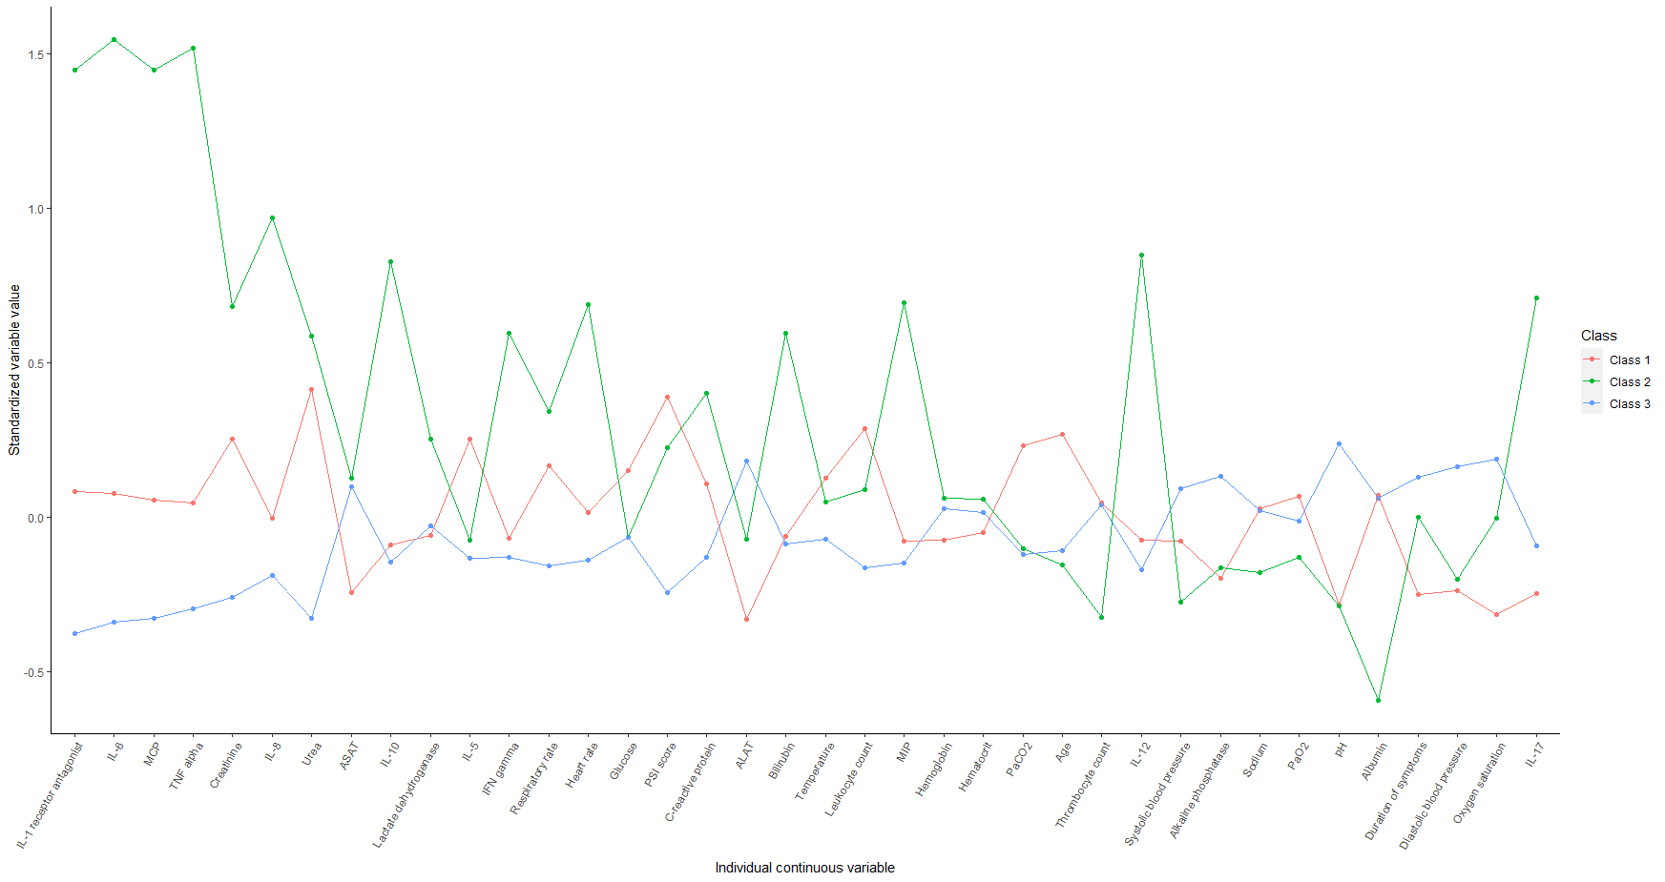
Four-class model Ovidius-TripleP cohort
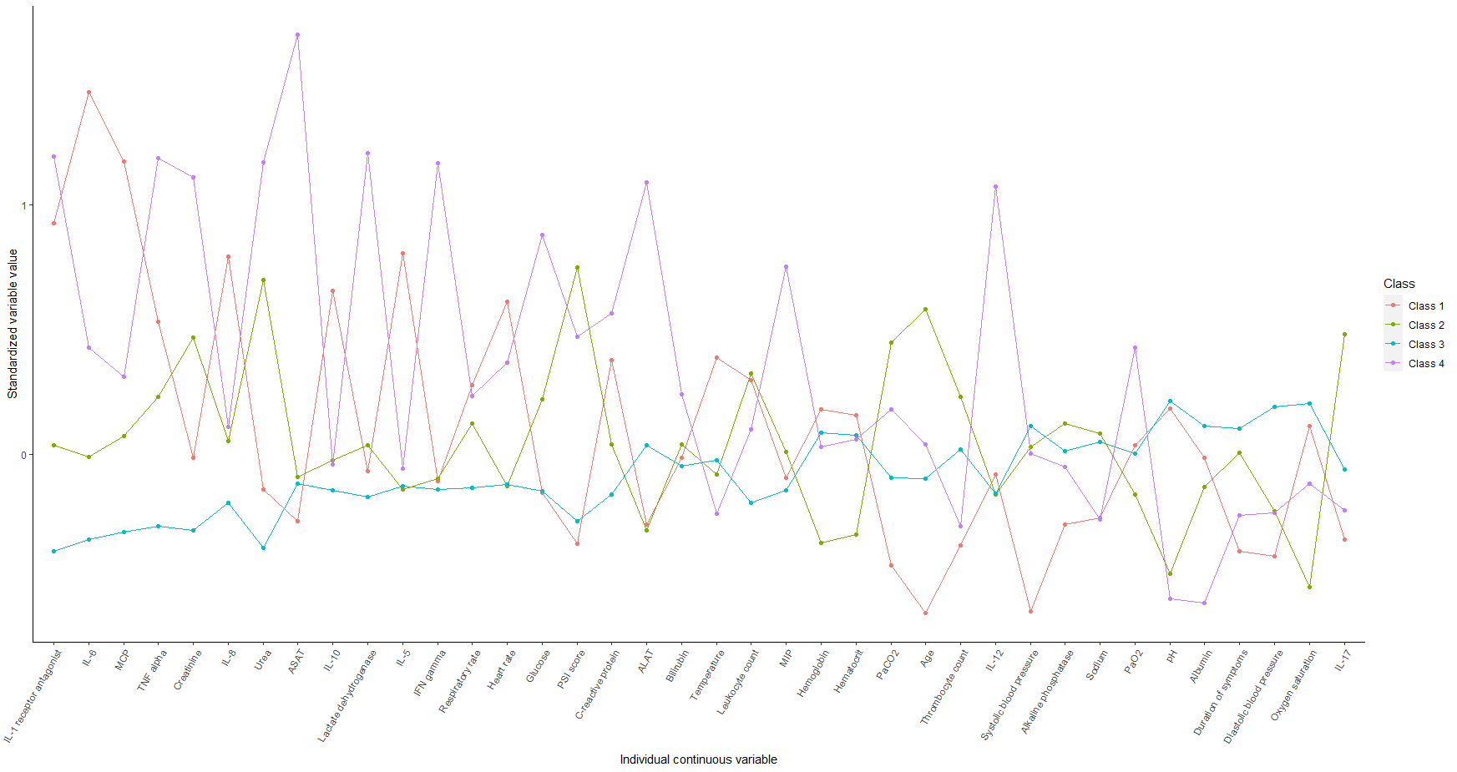

Five-class model Ovidius-TripleP cohort
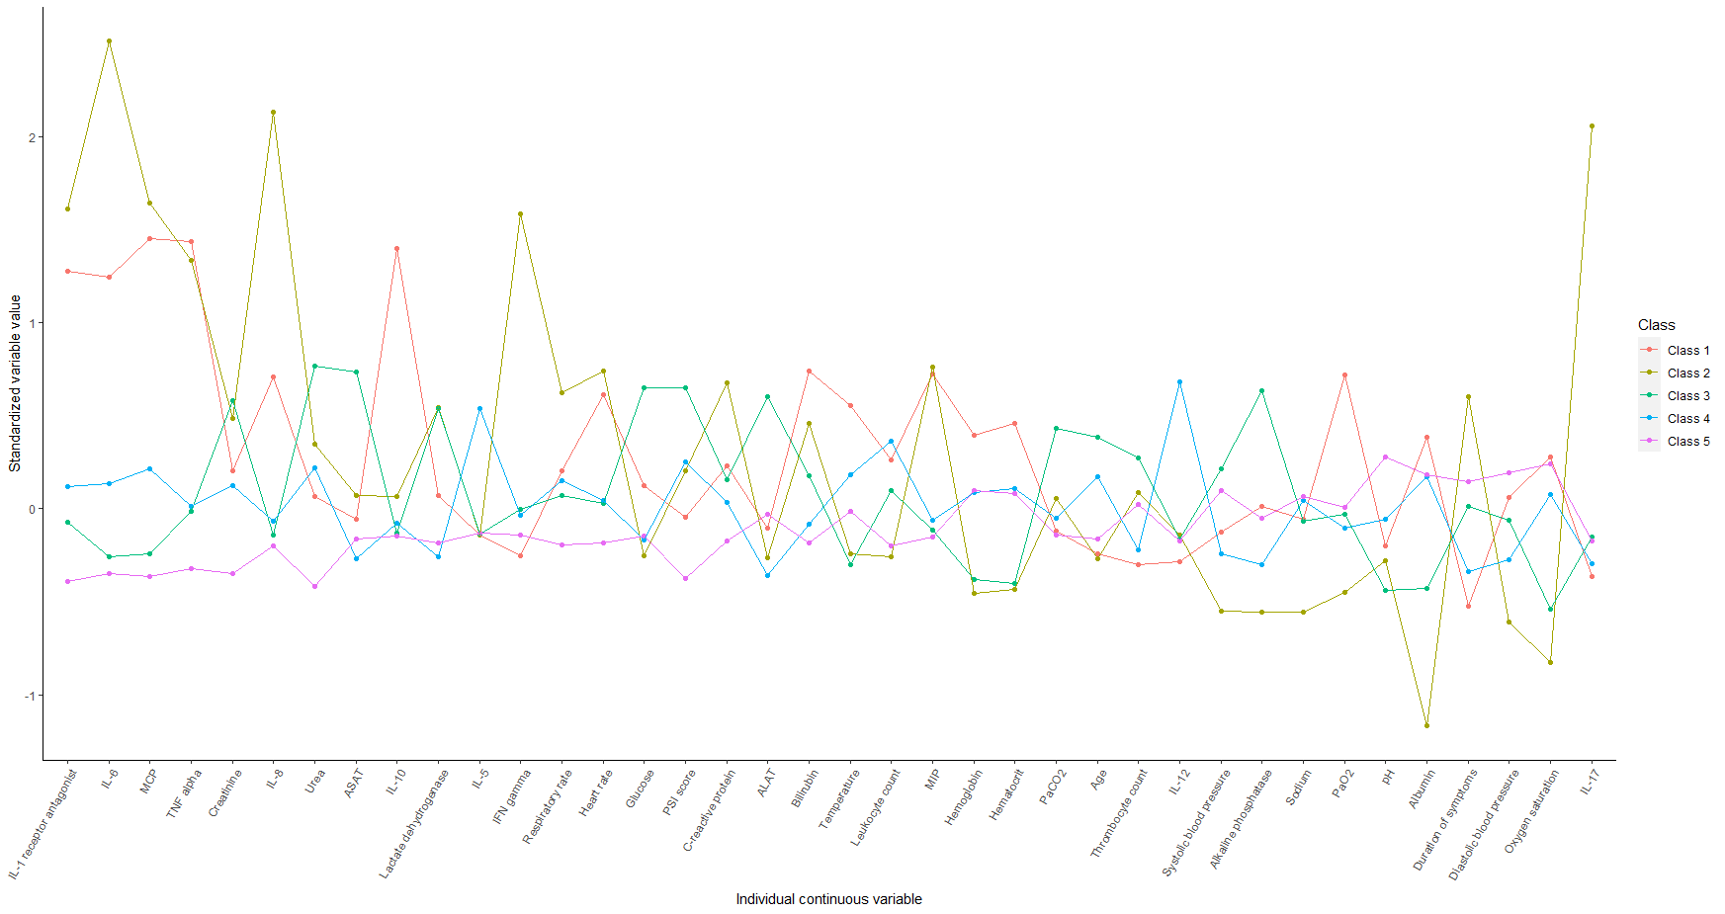

Abbreviations: IL= interleukin; MCP= Monocyte chemoattractant protein; TNF=Tumour necrosis factor; , ASAT= Aspartate transaminase ; IFN= Interferon; PSI= Pneumonia Severity index; ALAT=Alanine transaminase; MIP= Macrophage inflammatory protein.

eFigure 1B Continuous variables by class assignment in a three, four, or five-class model in the STEP cohort.
On the Y-axis differences in the standardised values of each variable by subgroup are shown. The individual continuous variables are shown along the x-axis. Variables are sorted by degree of separation between classes.

Three-class model STEP cohort
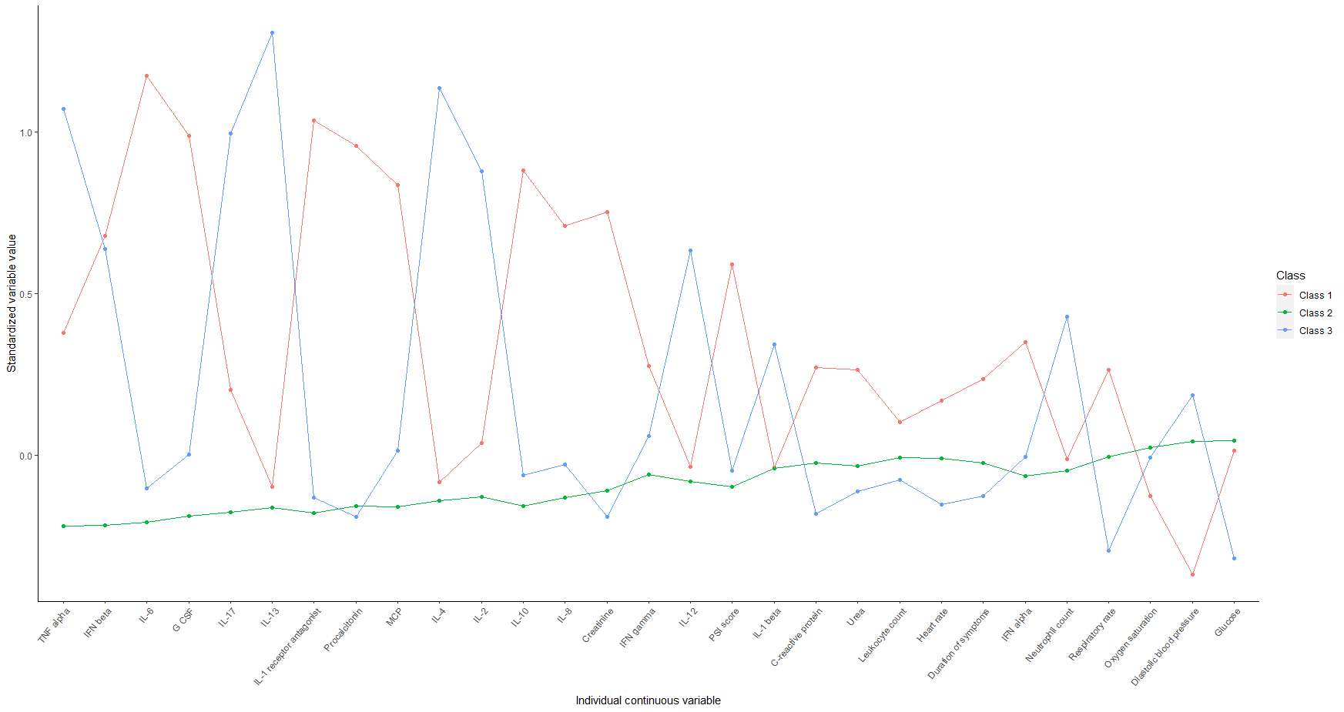

Four-class model STEP cohort
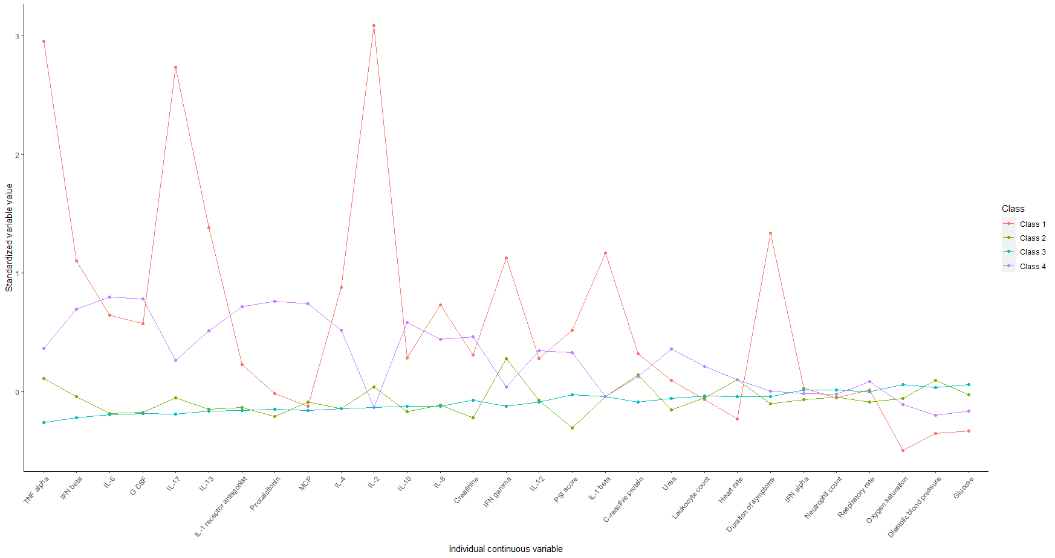

Five-class model STEP cohort
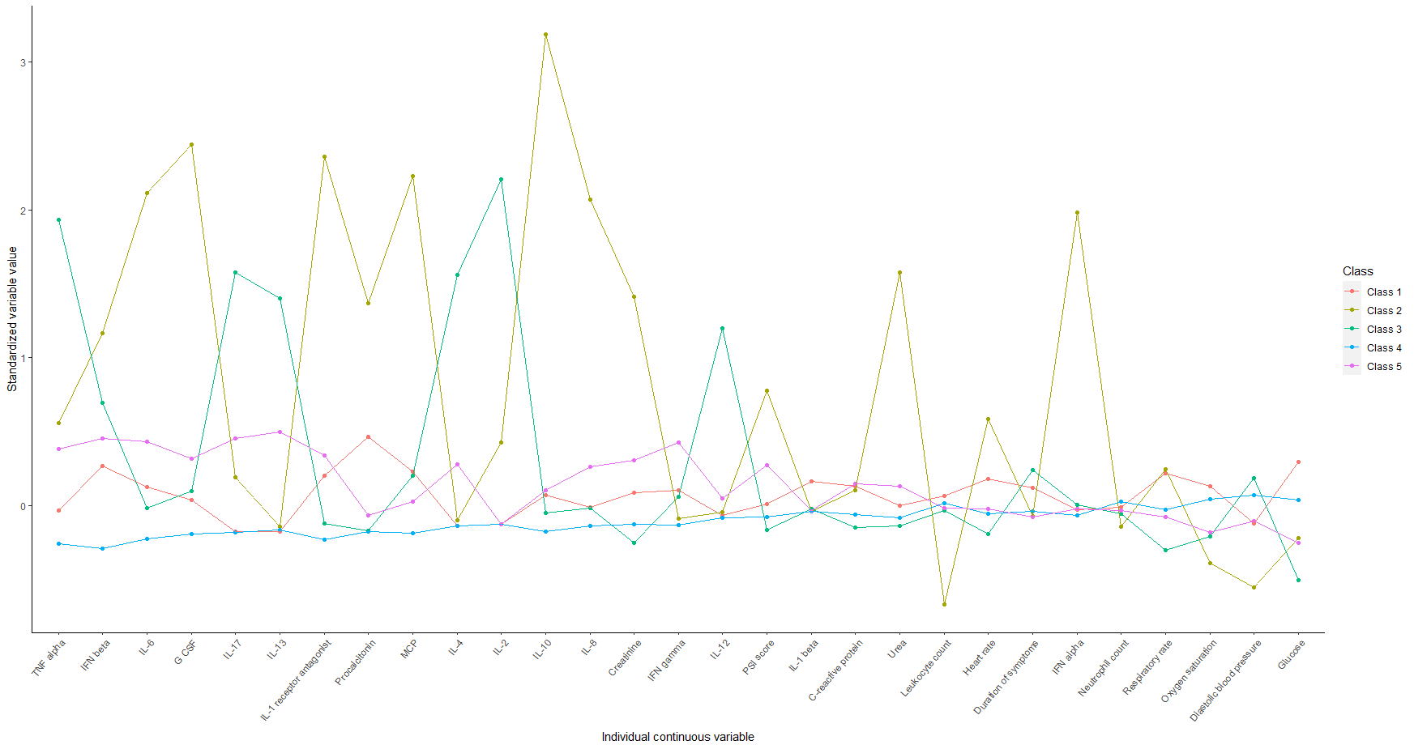

Abbreviations: IL= interleukin; MCP= Monocyte chemoattractant protein; TNF=Tumour necrosis factor; IFN= Interferon; PSI= Pneumonia Severity index; G-CSF= Granulocyte colony-stimulating factor.

4. eFigure 2
eFigure 2A: Probability of class assignment Ovidius-TripleP cohort in a two-class model
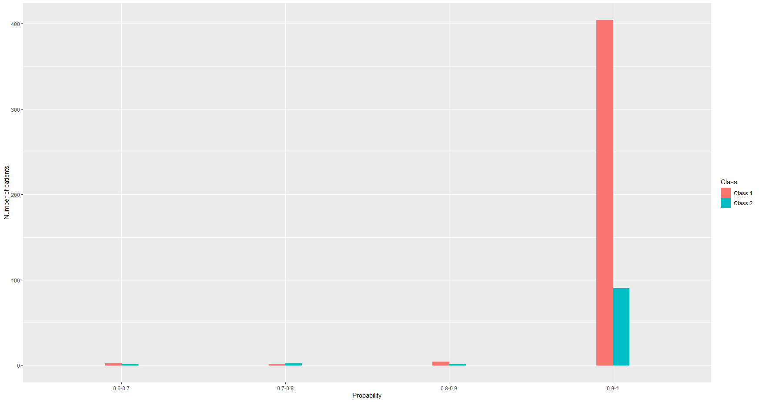
eFigure E2B Probability of class assignment STEP cohort in a two-class model
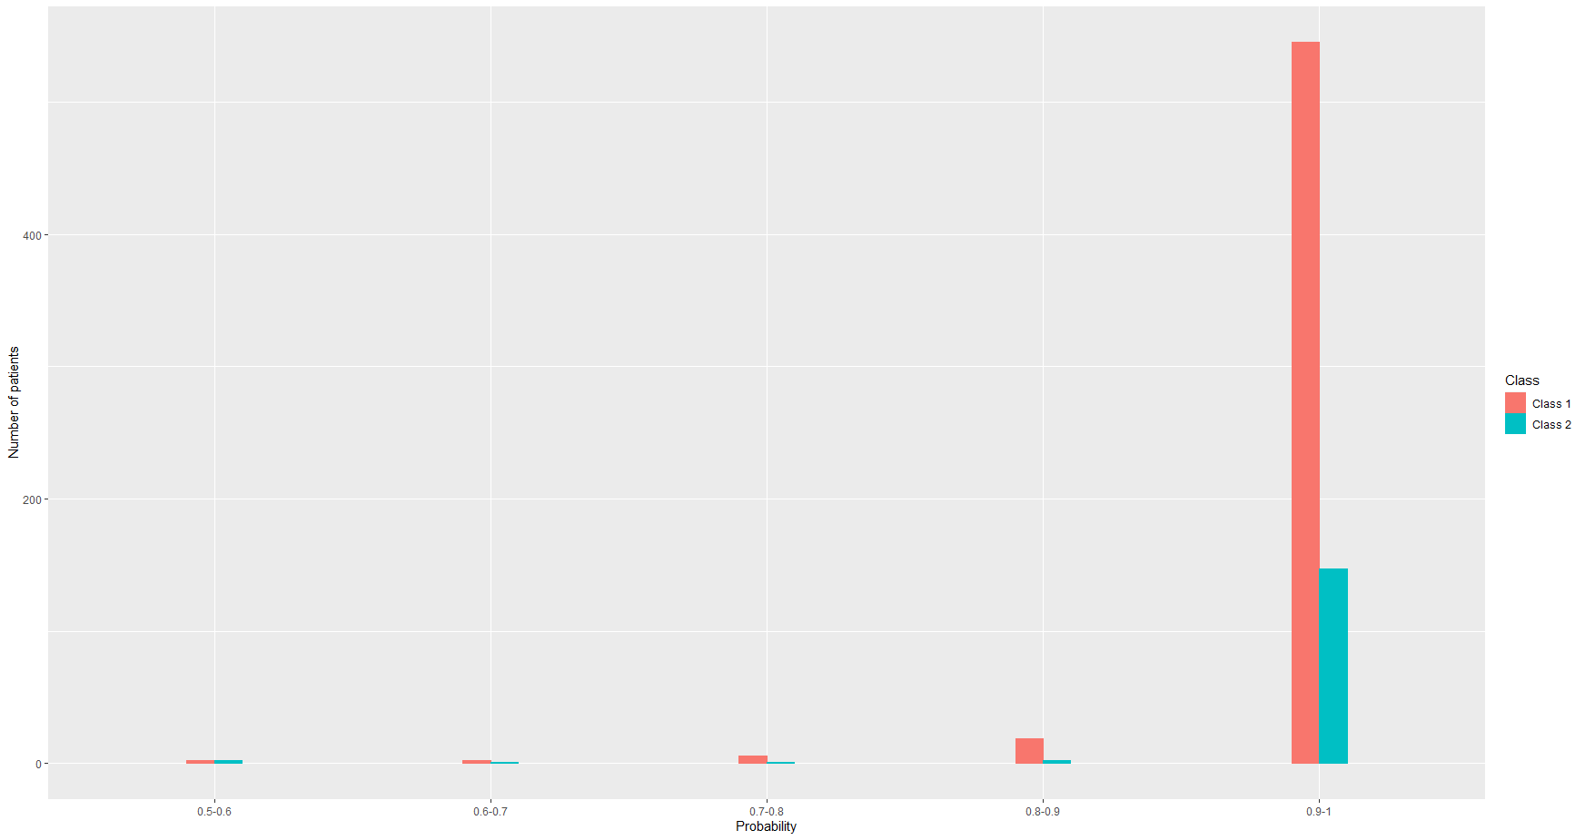
In the figures above the probability of class assignment is shown on the x-axis and the number of patients on the y-axis. This figure shows that the majority of patients had a chance of 90-100% of being assigned to the correct class. For subsequent analyses, patients were assigned to the class with the highest probability of assignment.

5. eTable 1 Baseline characteristics Ovidius-TripleP cohort and STEP cohort
 | Ovidius-TripleP cohort (n = 505) | STEP cohort (n = 727)
Demographic data
Age (years) | 67 (51-78) | 73 (60-83)
Male | 295 (58.4%) | 452 (62.2%)
Caucasian | 491 (97.2%) | 712 (97.9%)
Duration of symptoms (days) | 4 (2-7) | 4 (2-7)
Antibiotics at home | 130 (25.7%) | 164 (22.6%)
Corticosteroids at home | 34 (6.7%) | 14 (1.9%)
Comorbidities
Nursing home resident | 19 (3.8%) | 0 (0.0%)
Cerebrovascular accident | 46 (9.1%) | 67 (9.2%)
Malignancy | 45 (8.9%) | 70 (9.6%)
Liver disease | 2 (0.4%) | 28 (3.9%)
Renal disease | 40 (7.9%) | 218 (30.0%)
Congestive heart failure | 68 (13.5%) | 134 (18.4%)
Chronic obstructive pulmonary disease | 98 (19.4%) | 122 (16.8%)
Diabetes mellitus | 77 (15.2%) | 139 (19.1%)
Current smoker | 81 (16.0%) | 188 (25.9%)
Clinical data
Altered mental status* | 57 (11.3%) | 46 (6.3%)
Pleural effusion | 82 (16.2%) | 86 (11.8%)
Systolic blood pressure (mmHg) | 130 (118-146) | 124 (110-140)
Diastolic blood pressure (mmHg) | 75 (66-82) | 69 (60-78)
Heart rate (beats per minute) | 97 (84-111) | 83 (72-96)
Respiratory rate (breaths per minute) | 24 (20-30) | 20 (18-24)
Temperature (ºC) | 38.2 (37.4-39.0) | 37.6 (37.0-38.2)
Oxygen saturation (%) | 94 (91-97) | 94 (92-96)
Oxygen therapy (yes/no) | 100 (19.8%) | 377 (51.9%)
Oxygen therapy (L/min) | 1 (0-4) | 2 (2-4)
Pneumonia severity index score | 87 (63-114) | 90 (64-113)
Routine laboratory data
Leukocyte count (10⁹ cells per L) | 13.8 (9.7-18.4) | 12.0 (8.8-15.6)
Neutrophil count (10⁹ cells per L) | - | 9.9 (6.9-13.3)
Thrombocyte count (10⁹ cells per L) | 250 (197-318) | -
C-reactive protein (mg/L) | 210 (95-317) | 160 (79-249)
Procalcitonin (ng/mL) | - | 0.46 (0.17-2.50)
Hematocrit (L/L) | 0.40 (0.37-0.43) | -
Hemoglobin (mmol/L) | 8.3 (7.6-9.0) | -
Urea (mmol/L) | 6.8 (4.8-10.2) | 6.9 (4.9-10.4)
Creatinine (µmol/L) | 90 (71-112) | 88 (69-113)
Sodium (mmol/L) | 134 (131-137) | 137 (134-139)
Glucose (mmol/L) | 7.1 (6.0-8.6) | 7.3 (6.3-8.9)
pH | 7.47 (7.44-7.49) | -
PaO₂ (kPa) | 8.7 (7.7-10.3) | -
PaCO₂ (kPa) | 4.4 (4.1-4.9) | -
Alkaline phosphatase (U/L) | 90 (68-127) | -
Aspartate transaminase (U/L) | 35 (23-52) | -
Alanine transaminase (U/L) | 28 (17-45) | -
Lactate dehydrogenase (U/L) | 351 (255-518) | -
Bilirubin (µmol/L) | 13 (9-17) | -
Albumin (g/L) | 37 (33-39) | 32 (28-36)
Biomarker data
Interleukin-1 receptor antagonist (pg/mL) | 163.8 (25.1-694.7) | 33.0 (33.0-1126.5)
Interleukin-1 beta (pg/mL) | - | 1.0 (1.0-1.0)
Interleukin-2 (pg/mL) | - | 4.4 (4.4-4.4)
Interleukin-4 (pg/mL) | - | 5.5 (5.5-5.5)
Interleukin-5 (pg/mL) | 0.5 (0.3-0.7) | -
Interleukin-6 (pg/mL) | 72.0 (22.5-248.7) | 52.0 (19.0-142.8)
Interleukin-8 (pg/mL) | 18.9 (9.1-42.6) | 5.0 (2.0-13.0)
Interleukin-10 (pg/mL) | 4.5 (1.6-14.2) | 1.0 (0.7-1.9)
Interleukin-12 (pg/mL) | 7.4 (4.3-10.8) | 1.2 (1.1-1.7)
Interleukin-13 (pg/mL) | - | 1.3 (1.3-1.3)
Interleukin-17 (pg/mL) | - | 0.6 (0.6-0.6)
Tumor necrosis factor alpha (pg/mL) | 6.7 (3.6-12.4) | 1.7 (1.7-2.3)
Interferon alpha (pg/mL) | - | 0.3 (0.3-0.4)
Interferon beta (pg/mL) | - | 24.0 (15.0-41.0)
Interferon gamma (pg/mL) | 205.9 (12.8-298.6) | 2.8 (2.8-2.8)
Monocyte chemoattractant protein (pg/mL) | 317.6 (88.5-654.2) | 43.0 (27.0-84.8)
Macrophage inflammatory protein (pg/mL) | 6.3 (3.9-8.8) | -
Granulocyte colony stimulating factor (pg/mL) | - | 7.0 (7.0-13.0)
Causative microorganism
S. pneumoniae | 124 (24.6) | 106 (14.6)
H. influenzae | 27 (5.3) | -
Legionella species | 20 (4.0) | 13 (1.8)
C. burnetii | 28 (5.5) | -
Other | 96 (19.0) | -
None identified | 210 (41.6) | -
Outcome
Length of stay (days) | 8.5 (6.0-13.0) | 7.0 (4.0-10.0)
ICU admission | 38 (7.5%) | 39 (5.4%)
In-hospital mortality | 24 (4.8%) | 24 (3.3%)
30-day mortality | 26 (5.1%) | 28 (3.9%)
Readmission | 37 (7.3%) | 39 (5.4%)
Data are n (%), mean (SD), or median (IQR). * Defined as a state of awareness that differed from the normal awareness of a conscious person, scored by the attending physician.

6. eTable 2 Contingency tables comparing class membership in the reduced model and the full model for Ovidius-TripleP cohort and STEP cohort
Ovidius-TripleP |  | Full model
 |  | Class 1 | Class 2
Reduced model | Class 1 | 343 | 26
 | Class 2 | 68 | 68

STEP |  | Full model
 |  | Class 1 | Class 2
Reduced model | Class 1 | 515 | 90
 | Class 2 | 59 | 63

Data are n

7. Clinical characteristics for each class for a three-class model in Ovidius-TripleP and STEP cohort

eTable 3 Values of variables at baseline stratified by class in the Ovidius-TripleP cohort
Variable | Class 1 (n=153) | Class 2 (n=58) | Class 3 (n=294)
Temperature (ºC) | 38.4 [37.4 - 39.1] | 38.3 [37.4 - 39.2] | 38.1 [37.4 - 39.0]
Leukocyte count (10⁹ cells per L) | 15.7 [11.1- 20.6] | 13.6 [9.2- 18.5] | 12.6 [9.4- 16.6]
C-reactive protein (mg/L) | 235 [90 - 352] | 297 [110- 428] | 190 [97 - 271]
Age (years) | 72 [60- 81] | 66 [41- 76] | 63 [50 - 76]
Systolic blood pressure (mmHg) | 126 [112- 146] | 127 [112 - 143] | 134 [120 - 147]
Diastolic blood pressure (mmHg) | 70 [62 - 79] | 70 [60 - 80] | 77 [70 - 85]
Heart rate (beats per minute) | 100 [84 - 113] | 110 [99 - 126] | 94 [82 - 107]
Respiratory rate (breaths per minute) | 25 [20 - 30] | 25 [20 - 30] | 20 [18 - 30]
Hematocrit (L/L) | 0.39 [0.36- 0.43] | 0.40 [0.37- 0.43] | 0.40 [0.37- 0.43]
Urea (mmol/L) | 9.0 [6.3 – 13.7] | 9.8 [6.4- 15.3] | 5.7 [4.3 - 8.4]
Sodium (mmol/L) | 134 [131 - 137] | 133 [130 - 137] | 135 [132 - 137]
Glucose (mmol/L) | 7.3 [6.1 - 9.1] | 7.4 [6.2- 8.6] | 7.0 [6.0 - 8.3]
PaO₂ (kPa) | 8.70 [7.50 - 10.80] | 8.40 [7.68- 9.50] | 8.90 [7.90-10.22]
PaCO₂ (kPa) | 4.40 [4.10 - 5.10] | 4.55 [4.00 - 4.93] | 4.40 [4.00 - 4.73]
Creatinine (µmol/L) | 99 [81 - 134] | 107 [83 - 139] | 82 [68 - 100]
Alkaline phosphatase (U/L) | 86 [64 - 115] | 80 [61 - 110] | 96 [71 - 137]
Aspartate transaminase (U/L) | 32 [24- 43] | 47 [24 - 81] | 35 [23 - 60]
Alanine transaminase (U/L) | 22 [15 - 33] | 28 [20 - 45] | 32 [18 - 58]
Lactate dehydrogenase (U/L) | 370 [265 - 489] | 435 [304 - 547] | 326 [248- 502]
Bilirubin (µmol/L) | 13 [9 - 16] | 18 [14 - 26] | 12 [9 - 17]
Albumin (g/L) | 37 [33 - 40] | 35 [31 - 37] | 37 [34 - 39 ]
Hemoglobin (mmol/L) | 8.2 [7.5- 9.0 ] | 8.3 [7.8 - 9.0] | 8.4 [7.6 - 9.1]
Thrombocyte count (10⁹ cells per L) | 261 [197 - 315 ] | 228 [177 - 292] | 250 [201 - 324]
Oxygen saturation (%) | 93 [90 - 97] | 94 [91 - 96] | 95 [92 - 97]
Duration of symptoms (days) | 3 [2 - 5] | 4 [2 - 6] | 5 [3 - 7]
Interleukin-1 receptor antagonist (pg/mL) | 387.9 [72.9- 1538.6] | 1937.5 [628.4- 5823.8] | 56.4 [11.4- 242.2]
Interleukin-6 (pg/mL) | 220.6 [73.1 - 697.7] | 1427.2 [258.1 - 2922.7] | 35.6 [15.0 - 81.7]
Interleukin-8 (pg/mL) | 37.2 [19.5 - 60.9] | 113.6 [42.6 - 267.0] | 11.5 [6.6 - 19.1]
Interleukin-10 (pg/mL) | 11.1 [3.8- 28.9] | 55.6 [10.9- 179.6] | 2.2 [1.1- 4.8]
Pneumonia severity index score | 106 [76 - 129] | 95 [70 - 123] | 77 [56 - 102]
Tumor necrosis factor alpha (pg/mL) | 9.9 [6.5- 16.2] | 32.2 [11.1- 49.0] | 5.1 [2.6- 7.7]
Interferon gamma (pg/mL) | 239.1 [21.2- 312.5] | 195.0 [8.5- 406.7] | 182.9 [17.1- 266.9]
Monocyte chemoattractant protein (pg/mL) | 462.4 [143.9- 1122.0] | 1957.5 [327.3- 3124.5] | 226.9 [56.3- 425.0]
Macrophage inflammatory protein (pg/mL) | 7.2 [4.9- 9.3] | 7.2 [5.2- 12.2] | 5.4 [3.4- 7.2]
Interleukin-12 (pg/mL) | 9.3 [5.1 - 12.3] | 8.5 [5.6 - 11.7] | 6.5 [3.8- 10.0]
Interleukin-5 (pg/mL) | 0.54 [0.32- 0.81] | 0.42 [0.22- 0.60] | 0.52 [0.23- 0.67]
pH | 7.45 [7.42 - 7.48] | 7.45 [7.42 - 7.48] | 7.48 [7.45 - 7.50]
Cortisol (nmol/L) | 328.6 [225.7 - 540.3] | 526.7 [339.3 - 774.7] | 195.8 [133.6 - 305.2]
Altered mental status | 26 (17.0) | 4 (6.9) | 27 (9.2)
Pleural effusion | 29 (19.0) | 15 (25.9) | 38 (12.9)
Oxygen therapy | 43 (28.1) | 18 (31.0) | 39 (13.3)
Female | 67 (43.8) | 23 (39.7) | 120 (40.8)
Data are n (%) or mean (SD).

eTable 4 Values of variables at baseline stratified by class in the STEP cohort
Variable | Class 1 (n=99) | Class 2 (n=556) | Class 3 (n=72)
C-reactive protein (mg/L) | 190 [72 - 294] | 168 [81 - 250] | 127 [67 - 210]
Diastolic blood pressure (mmHg) | 65 [57 - 72] | 70 [60 - 78] | 69 [60 - 80]
Heart rate (beats per minute) | 88 [72 - 104] | 84 [73 - 95] | 82 [70 - 95]
Respiratory rate (breaths per minute) | 22 [18 - 26] | 20 [18 - 24] | 20 [16 - 24]
Urea (mmol/L) | 9.3 [6.4 - 14.8] | 6.6 [4.8 - 9.8] | 7.0 [4.5 - 9.9]
Glucose (mmol/L) | 6.5 [5.6 - 7.7] | 6.5 [5.7 - 7.8] | 5.8 [5.2 - 6.5]
Creatinine (µmol/L) | 109 [85 - 177] | 86 [67 - 108] | 84 [70 - 106]
Leukocyte count (10⁹ cells per L) | 11.5 [7.4 - 17.1] | 12.0 [8.7 - 15.9] | 12.1 [9.3 - 14.6]
Oxygen saturation (%) | 94 [92 - 97] | 95 [92 - 96] | 94 [92 - 96]
Pneumonia severity index score | 106 [78 - 141] | 89 [63 - 111] | 82 [63 - 105]
Duration of symptoms (days) | 4 [2 - 7] | 4 [2 - 7] | 4 [2 - 6]
Granulocyte colony stimulating factor (pg/mL) | 33.0 [13.0 – 114.3] | 7.0 [7.0 – 8.0] | 14.0 [7.0 – 22.5]
Interferon alpha (pg/mL) | 0.67 [0.39 - 1.24] | 0.25 [0.25 - 0.30] | 0.51 [0.27 - 1.10]
Interferon beta (pg/mL) | 58.0 [34.0 - 106.5] | 22.0 [14.0 – 33.0] | 30.0 [17.0 – 55.0]
Interferon gamma (pg/mL) | 2.8 [2.8 - 3.8] | 2.8 [2.8 - 2.8] | 2.8 [2.8 - 4.2]
Interleukin-1 beta (pg/mL) | 1.0 [1.0 - 1.3] | 1.0 [1.0 – 1.0] | 1.0 [1.0 - 3.5]
Interleukin-1 receptor antagonist (pg/mL) | 5375.0 [1466.0 - 11687.3] | 33.0 [33.0 – 495.0] | 33.0 [33.0 – 733.0]
Interleukin-10 (pg/mL) | 3.2 [2.1 - 13.1] | 0.9 [0.6 - 1.3] | 1.5 [1.0 - 2.7]
Interleukin-12 (pg/mL) | 1.8 [1.1 - 2.8] | 1.1 [1.1 - 1.4] | 2.0 [1.2 - 4.5]
Interleukin-13 (pg/mL) | 1.3 [1.3 - 2.5] | 1.3 [1.3 - 1.3] | 4.0 [1.3 - 13.3]
Interleukin-17 (pg/mL) | 0.6 [0.6 - 1.4] | 0.6 [0.6 - 0.6] | 0.8 [0.6 - 1.7]
Interleukin-2 (pg/mL) | 4.4 [4.4 - 4.4] | 4.4 [4.4 - 4.4] | 4.4 [4.4 - 4.4]
Interleukin-4 (pg/mL) | 5.5 [5.5 - 6.9] | 5.5 [5.5 - 5.5] | 9.0 [5.5 – 32.6]
Interleukin-6 (pg/mL) | 540.5 [125.5 - 1422.5] | 41.0 [15.0 – 97.0] | 73.0 [28.5 - 170.5]
Interleukin-8 (pg/mL) | 39.0 [17.8 – 81.0] | 4.0 [2.0 – 9.0] | 7.0 [4.0 - 16.5]
Monocyte chemoattractant protein (pg/mL) | 168.0 [71.3 - 400.3] | 39.0 [25.0 – 66.0 ] | 45.0 [27.0 - 74.5]
Tumor necrosis factor alpha (pg/mL) | 2.8 [1.7 - 3.9] | 1.7 [1.7 - 1.8] | 2.5 [1.7 - 3.5]
Procalcitonin (ng/mL) | 3.00 [0.60 - 26.36] | 0.38 [0.16 - 1.88] | 0.39 [0.16 - 1.14]
Neutrophil count (10⁹ cells per L) | 10.8 [6.6 - 15.4] | 9.8 [6.9 - 13.3] | 10.1 [7.6 - 12.1]
Altered mental status | 8 ( 8.1) | 31 ( 5.6) | 7 ( 9.7)
Pleural effusion | 8 (8.1) | 58 (10.4) | 17 (23.6)
Oxygen therapy | 60 (60.6) | 264 (47.5) | 53 (73.6)
Female | 31 (31.3) | 206 (37.1) | 38 (52.8)
Data are n (%) or mean (SD).

eTable 5. Association between class assignment and clinical outcomes
Ovidius-TripleP cohort
Clinical outcome | Class 1 (n = 153) | Class 2 (n = 58) | Class 3 (n = 294) | p-value
Length of stay (days) | 9.0 (7.0-14.0) | 10.3 (6.0-23.8) | 8.0 (5.5-11.5) | <0.01
ICU admission | 12 (7.8) | 14 (24.1) | 12 (4.1) | <0.01
In-hospital mortality | 11 (2.7) | 6 (10.3) | 7 (2.4) | <0.01
30-day mortality | 13 (8.5) | 6 (10.3) | 7 (2.4) | <0.01
Readmission | 11 (7.2) | 4 (6.9) | 22 (7.5) | 0.98

STEP cohort
Clinical outcome | Class 1 (n = 99) | Class 2 (n = 556) | Class 3 (n = 72) | p-value
Length of stay (days) | 8.0 (5.0-13.0) | 7.0 (4.0-10.0) | 7.0 (5.0-10.3) | <0.01
ICU admission | 12 (12.1) | 26 (4.7) | 1 (1.4) | <0.01
In-hospital mortality | 11 (11.1) | 11 (2.0) | 2 (2.8) | <0.01
30-day mortality | 10 (10.1) | 16 (2.9) | 2 (2.8) | <0.01
Readmission | 8 (8.1) | 27 (4.9) | 4 (5.6) | 0.42
Data are N (%) or median (IQR). ICU intensive care unit.

